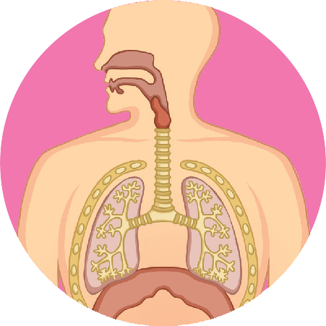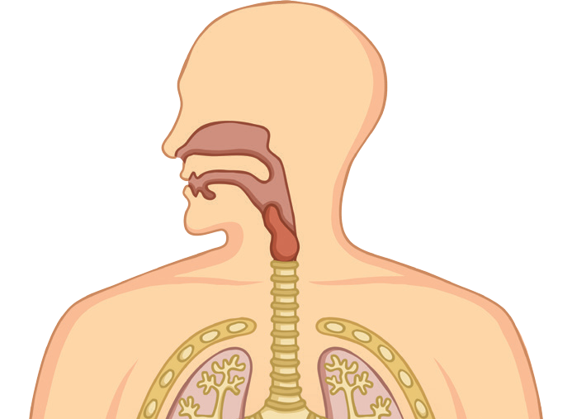True or False The Cardiovascular and Respiratory Systems
1 The systemic circuit transports oxygenated blood from the heart around
the body.
2 The pulmonary circuit transports deoxygenated blood from the
heart around the lungs.
3 Arteries transport deoxygenated blood from the heart to muscles
and organs.

4 Capillaries have thick walls and move blood back to the heart.

5 Heart rate is the number of beats per minute.

6 The vena cava carries oxygenated blood to the heart.

7 Gaseous exchange takes place in the alveoli.

8 The volume of air inspired or expired during each breath is known as breathing rate.

9 Respiration is the act of breathing in.

10 Sport or activity that raises the heart and breathing rate which can be sustained over time is known as ‘aerobic’.

Extension
True or False The Cardiovascular and Respiratory Systems

Create a further five true or false questions on the cardiovascular and respiratory systems.

1

2

3

4

5

